“Thank You” Email Template - simplified.

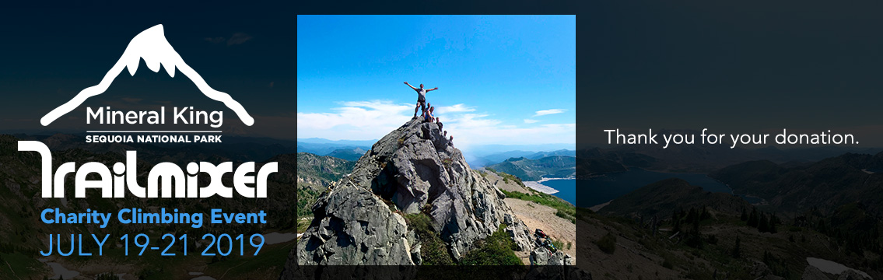

[NAME],

Thank you very much for your support.

Your donation will help fund a summer camp scholarship program at Camp Brave Trails – a summer camp for LGBTQ+ youth that fosters leadership skills, community building, self-realization, and public service. Kids come from all over the U.S., and the camp experience is often the first time they meet others like themselves. It is truly a positive, life-changing and transformative experience.

Your donation is making all the difference in these kids’ lives. So, thank you!

Best,

[YOURNAME]

CLICK TO DONATE
https://www.gofundme.com/2019-trailmixer-3day-charity-climbing-event

Or go to
Trailmixer.org

